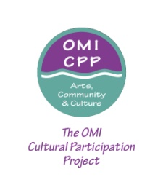Ocean Avenue Arts& Culture Festival- Vendor Application
Saturday, September 20, 2014
11 am- 4 pm
Deadline-August 29, 2014

Join us for the Ocean Avenue Arts & Culture Festival, an event to celebrate the OMI Community! We are looking to attract Arts & Craft, Novelty, Commercial Businesses,
Food Vendors, and local non-profits.

Prices for all tables (2 tables under a 10x10 tent—usually one table per business or organization is to be purchased unless you want the whole space, then the amount doubles.) listed below:

Faxon Avenue non-profits,arts and crafts, and food vendors- $50.00 for table, tent space and two chairs.

No refunds will be issued for tabling fees, regardless of the circumstance.

Vendor Information

Contact Name:_________________________________________________________

Company:_____________________________________________________________

Street Address_________________________________________________________
State_________ Zip Code_____________ Phone No,________________________

E-Mail______________________ Circle One: Artist - Non-Profit - Merchant -Other

Brief Description of your work/products/items__________________________________________________

Send form and check if applicable to: The OMI Cultural Participation Project
200 Grafton Avenue, S.F., CA 94112 or mariafepicar@comcast.net

